SyncPlate: Connecting all automobiles through their Licence plates

**Nature of work:**

Novel solution/Indigenous design to a problem/challenge

**Rationale:**

As the urban populations increase, the need appropriate solutions for traffic congestion, road safety, and response time to emergencies rise commensurately. Established traffic systems fail due to a lack of proper real-time data exchange at the right time, causing inefficient traffic flow, emergency late arrival, and increases the likelihood of accidents.

The E-Plate system allows the connected vehicles to wirelessly share with each other the real-time data on the traffic and road conditions for a smarter and safer driving.

**Scientific Concepts Used :**

* Data Aggregation
* Mesh networking
* IoT & Supporting technologies like i2C , i2S

**Materials Used :**

* ESP32 S3
* TP4056 for power management
* loRA module
* Inductor-based custom noise isolation circuit
* Custom PCB to house everything in an assembly

**Procedure:**

1. **PCB Assembly**

Based on our custom PCB design, assemble the board with respect to the given BoM file or get it fabricated and manufactured by any distributor.

1. **Registration and Identification**

Once the assembly has been completed, you can register the license plate with the government which you would then attach to your vehicle making it legal to drive.

**Overview:**

The e-plates represent one of the advanced projects for infrastructure and road safety improvement in intelligent electronic plates of an automobile. In principle, they should be able to use microcontrollers like ESP32 effectively to exchange data in real-time between vehicles and the central system managing the traffic. The basic premise is making the use of E-plates in all cars compulsory to set up a connected-vehicle hive-mind type of environment, which should enable vehicles to share key information about traffic conditions, road safety risks, and more.

**Features:** Central to the E-plate system is an ESP32 microcontroller integrated with a LoRa module for long-range communication, a battery for autonomous power supply, and the necessary circuitry for battery charging. Thus, every vehicle fitted with an E-plate becomes a data node that can detect and transmit information about road conditions. The features would include:

**Traffic Bottlenecks:** E-plates can sense traffic congestion and, further, disseminate such information in real-time to other vehicles as well as the central system, for dynamic route adjustments to avoid congestion.

**Road Hazards:** These potholes, debris, or wet road surface data are swapped with the E-plates of oncoming cars, hence creating live-time alerts that enhance the safety of the roads by transmitting that very data to cars that are already approaching that route.

**Accidents and Emergencies:** If an accident should occur, the vehicles with the E-plates automatically will communicate their location and allow rerouting of traffic along with sending emergency services to the location. This is a very important function in the case of an ambulance because the fastest and safest route to any particular destination will be found, considerably saving on response time.

Application :

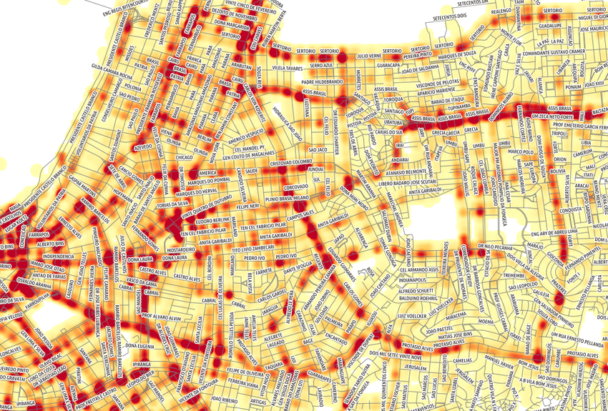

Given that this system is implemented, this would give us so many such heatmaps of traffic, helping us understand where the distribution must be splitting, helping further in the distribution of traffic.

**Addressing Privacy Concerns:** Privacy is a key consideration for the E-Plate system. Data collected from vehicles is only collected if there is an influx of vehicle density or any issue reported from the user side, and then the data is only retained for short periods, used strictly for real-time traffic management, and discarded after processing, ensuring minimal risk of data misuse or tracking.

**Applications**

The implementation of the E-Plate system can lead to the creation of detailed heat maps of traffic conditions, which can help in optimizing traffic distribution and improving overall traffic management. By providing real-time data on traffic patterns, road conditions, and accidents, the system enables better decision-making for urban planning and traffic control.

**Conclusion**

The E-Plate system represents a significant advancement in intelligent traffic management and road safety. By integrating modern technologies with practical applications, the E-Plate system offers a novel solution to some of the most pressing challenges in urban traffic management, providing a safer, more efficient driving experience for all road users.

References:-

* **Vehicular Ad Hoc Networks (VANETs): Status, Results, and Challenges (IEEE Network, DOI: 10.1109/MNET.2015.7113225)**
* **Fog Computing and its Role in the Internet of Things (IEEE Internet of Things Journal, DOI: 10.1109/JIOT.2015.2468444)**
* **Collaborative Heatmap Generation for Real-Time Traffic Monitoring Using Crowdsourced Data (ACM SIGSPATIAL, DOI: 10.1145/3048903.3048939)**
* **Spatio-temporal Data Analytics for Real-time Traffic Monitoring and Prediction (Elsevier \Information Systems, DOI: 10.1016/j.is.2019.101475)**